Fiber to the home (FTTH) Development in the United States

**Abstract**

**Introduction**

While most Americans have access to broadband internet, the ways they get connected to the internet are quite different. Fiber to the home (FTTH) is considered a more advanced way to transmit data. Compared with more traditional cable modem and dial-up lines, FTTH is faster and more reliable, and can be implemented for long distance with a lower loss of information. For internet service providers (ISPs), the FTTH transmission also holds many advantages including lower loss than other technologies, since it is not affected by ground currents and other power signals. FTTH can thus obtain higher carrying capacity and longer transmitting distance. However, we can’t expect everyone to start benefiting FTTH internet soon as the technology becomes available. Even though the cost of FTTH has dropped significantly since 2000, ISPs are still contemplating if digging holes on the ground and implementing new lines will give them competitive advantages. In this project, we want to explore the FTTH development in the United States and how ISPs deployed this technology for their benefits in recent years.

**Data Source**

*Broadband Data:*

The main dataset we use in analyzing broadband development is the Fixed Broadband Deployment Data from Federal Communications Commission (FCC) website. We have 8 datasets in total. The earliest data available is in December 2014 and the latest data available is in June 2018. The data are collected twice a year, namely every June and December. Each dataset contains the broadband information for all census blocks in the US, including the Max Up/Downstream speed/bandwidth, the number of service receivers, and the name of the service provider, etc. For this report, we only focus on residential data.

*Population Data:*

We obtain block-level population data from the United States Census Bureau. The dataset contains the block number, population and the number of households. We use these population factors to analyze FTTH development.

*Funding Data:*

For each state, we collect funding data in terms of federal funding and state funding from the National Telecommunications and Information Administration and the website BroadbandNow.com. Later, we use these data to analyze the role government playing for FTTH development.

**Data Processing Pipeline**

The FCC broadband dataset is at block and provider level. Each row of the data contains the census block code and the ISP company information if it provides service to this block. The dataset indicated the type of connection, whether business or residential, in this report, we only considered residential connections. The dataset also provides the technology code indicate the type of technology used by the specific ISP in this block, we generalize the technology into 4 groups, DSL (Asymmetric xDSL, ADSL2, ADSL2+, VDSL, Symmetric xDSL and other copper wirelines.), DOCSIS(Cable Modem), FTTH (Optical Carrier, Fiber to the home) and others.

A major challenge for FTTH analysis is the massive amount of data. An ISP operates in a census block with a type of technology is a row in the dataset, in which if an ISP offered both ADSL2+ and FTTH for a same block, that would be 2 rows, and if 5 such ISP have same connections offered in the same block, there would be 10 lines. There are 11,155,486 census blocks in total. Our dataset in average contains more than 23 million rows for each half year, which boost the total dataset to more than 60 GB in size. Manipulating 60 GB data is different with other analytics tasks; therefore, we built a high-performance big data pipeline on Google Cloud to manage, retrieve and process the dataset.

*Figure 1*

As shown in figure 1, we used WGET to download raw data from FCC server and use ubuntu MySQL agent to load the data into our MySQL database, which also sits on Google Cloud. We indexed the tables for faster retrieves in the future. We then use the SQL command through Python to fetch data and save as csv. Since FCC only provides block code, we need to merge the dataset with the census dataset to get population information for each block, then we can calculate the total population covered by each technology, ISP, and state etc. We will use the population information a lot in later analysis. The most intuitive way to achieve the goal is joining the tables on block code. However, this method will be very costly since we are joining a table with 22 million and another table with 11 million, and we are going to do that 8 times. Instead, we developed a smarter method which save us tons of time in computation. We execute grouping and filtering as usual in MySQL to get information we need but return a list of block codes for each object we want to study. Since we used pandas and sql-alchemy agent in python, the result will be saved as pandas data frame. We then used the census population information and made a has table for each state, the key is block code and value is population for this block. Lastly, we divide the data frame by state and search the corresponding hash table to get the population count, then sum them up to generate results. Since searching the hash table tasks O(1) time and pandas computation are in memory, we can obtain the result in less than 15 mins, in compare of hours in SQL database. The processed data is relatively small in size and we can model or plot them easily.

**Overall Development countrywide**

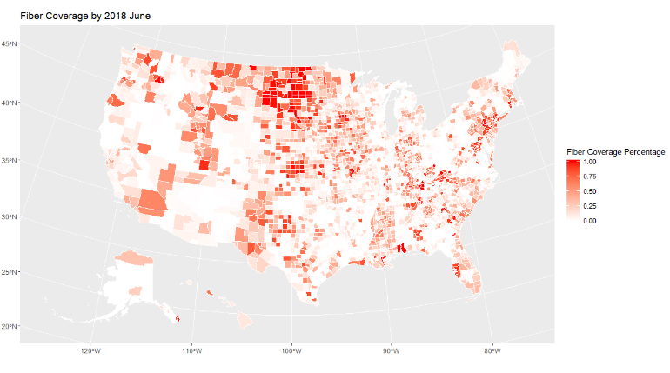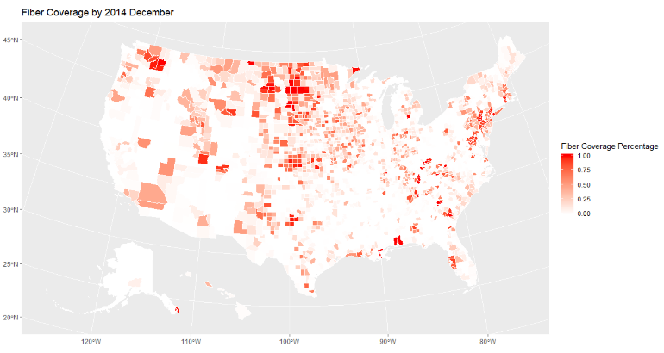

*Figure 2*

The left map of figure 2 shows the national FTTH coverage as of December 2014. The shade of color indicates the percentage of population in the county that has access to FTTH connections from at least one ISP. The right map shows the FTTH coverage as of June 2018. The maps are generated based on the block level FCC broadband data collected in these two periods using the following formula:

We aggregated the block level data based on the population to form the maps at county level. As the graph shows, there has been significant progress in FTTH expansion from 2014 to 2018 in the United States. As shown in the figure 2, more than half of the counties already have fiber access by the end of 2014. Most counties in the northern part of Midwest region and around New York City have the fiber access while counties in the south and Florida region are mostly not covered.

While in June 2018, the major fiber expansion happened in south and Texas.

*Figure 3*

We can compare this graph with a county level income graph as shown in figure 3 above. We can observe similar patterns in both figure 3 and right part of figure 2. Counties with a high FTTH coverage tends to have higher median income, in other words, ISPs are more likely to deploy FTTH in higher income regions.

**ISPs’ actions on FTTH development**

In June 2018, there were 1900 internet service providers operates in the U.S. and 956 of them provide FTTH services. In December 2014, there were 1674 ISPs and only 688 of them provide FTTH services. The portion of ISPs that serve FTTH technology had been grown from 41% to 50%. The figure 4 below shows which ISPs contribute the most in the huge step of FTTH development.

*Figure 4*

The x-axis represents the change of total population covered by FTTH from 2014 to 2018. The y-axis is the overall population covered by the ISP in 2018, and the shade of circle color shows the portion of population (total, not only FTTH) covered by this ISP, that has options for high-speed connections (maximum speed over 100Mbps). We can observe from the figure 4 that, as the biggest ISP in the U.S., AT&T is also the most pioneering ISP to deploy FTTH. AT&T initialized an important project for building “Ultra-Fast Fiber Network” in 2014, and we will elaborate on their massive expansion in California and Texas in later sections. Verizon has “lost” 5.6 million population in coverage, this is due to a large sale in 2016; Frontier Communications acquired services from Verizon in Texas, Florida, and California, for $1.8 billion. This event can also partially explain the fact that Frontier Communications Corp has ranked 2nd in FTTH coverage increase in the above figure. Since Verizon has served FTTH to a huge population, it might be strategic for them to sell some of their services to other expanding ISPs to gain cash flow for development such as 5G network, and meanwhile still not losing the leading position. Comcast and Charter Communications, the holding company for spectrum, are the two very large ISPs that are reluctant on FTTH deployment. From the color shade we can tell that, most of their coverage have maximum of download speed over 100 Mbps, which gives them little incentive to invest in building FTTH networks.

*Figure 5*

Figure 5 shows the ISP status as of June 2018. Comcast and Charter uses DOCSIS technology for almost all of their services. Comcast is the second largest broadcasting and cable television company in the world by revenue; it is reasonable for them to use the existing cable to provide internet service. The internet speed through TV cable has been increased significantly since the DOCSIS 3.0 in 2006, and now it can support download speed up to 500Mbps. Noted the largest ISP, AT&T, has a very large portion of coverage with the DSL technology. Since AT&T is the largest telephone service provider in the U.S, it is also advantageous for it to use the existing telephone networks to provide internet services. However, DSL connection is lower in speed, usually around 10 Mbps. The newer ADSL2+ technology can boost the speed to 25 Mbps but it’s still less advanced since FTTH can provide up to 1000 Mbps. In figure 4, the color of AT&T shows its high-speed coverage is very limited, which can explain AT&T’s strategy to grow FTTH network massively in the past 4 years. We can observe the similar strategy for other FTTH leaders, Verizon, CenturyLink and Frontier, and they all have a large DSL coverage. Therefore, these ISPs have less competitive advantage in high speed connections, which is highly demanding nowadays due to the raise of video content entertainments such as Netflix and YouTube. Under this condition, these ISPs have incentive to deploy FTTH for future competition.

*Figure 6*

We analyze the ISPs further with figure 6. The x-axis shows the total population covered and the y-axis shows the FTTH covered population. We used log base 10 on both axes to make the graph less sparse. We also made two reference lines on 95% percental marks; the right side of the vertical reference line represents companies which cover more population than the 95% companies. The part above the horizontal reference line represents companies cover more population with FTTH than the 95% companies. Therefore, we can use the four quadrants to categorize the ISPs. [1]

Companies in the first quadrant are the “super stars”. These ISPs are leading in both total coverage and FTTH coverage. Many well-known companies are in this category, such as AT&T, Verizon, Frontier, and CenturyLink. The Second quadrant are the “FTTH Pioneers”. They are the leaders in FTTH coverage but not total coverage. These ISPs are not historically big players but have been focusing on FTTH technology and play an important role in FTTH development. ISPs in the third quadrant are relatively small ISPs, note that the ISPs on the diagonal means almost all of their converge is through FTTH. ISPs in the fourth quadrant are reluctant to deploy FTTH technology, such as Comcast discussed above. These ISPs usually have invested a lot in DOCSIS network and thus less interested in FTTH.

**Government Funding**

We have found that some big ISPs that highly rely on DOCSIS have little incentive to deploy FTTH, since they can achieve over 100 Mbps download speed with upgraded TV Cable and also, FTTH deployment is expensive. Based on a June 2018 estimate[2] from a public traded ISP, OTELCO, the construction cost for FTTH is between $18,000 and $22,000 per mile, plus about $600 cost to deliver service from street to home. Considering the cost of FTTH subscription fee, usually below $100, it would take a long time for an ISP to cover the cost and that might make the ISPs more reluctant on FTTH development.

To encourage broadband development, each state and federal set up grants for qualified ISPs to build infrastructure and provide higher speed internet. Since 2010, National Telecommunications and Information Administration has invested more than $4 billion in 233 Broadband Technology Opportunities Program projects. Each state also has their broadband initiative to facilitate the integration of broadband and information technology into state and local economies. FTTH technology can easily achieve broadband standard speed, and it is a better choice for building new network since it has the highest maximum speed over all technologies. FTTH is favored by ISPs in their future internet development. We used an OLS estimation for each state to inspect whether the government broadband funding has positive effect on FTTH expansion. We used state intuitive and federal grants as independent variables to predict the overall change of FTTH covered population from 2014 to 2018. Table 1 shows the statistic model result.



*Table 1*

State initiative has a larger effect on getting more people covered by FTTH than federal grant, and they both have positive effects. Figure 7 below shows a more intuitive look that plot the total population change and total funding provided by government.

*Figure 7*

The general trend is positive, and we want to examine in detail what caused the big improvement in California and Texas.

As shown in Figure 7, California is located at the top right of the graph which indicates that California receives most government funding and helps second most population to get covered by FTTH technology out of all states. From our data, we find that California gets nearly $360 million grant from the government and increases FTTH covered population by 5 million from 2014-2018. According to the website broadbandnow.com, since 2010, California Public Utilities Commission has been awarded $7,981,304 in federal grants for California's Broadband Initiative. Another $350,064,330, accounting for 10.0% of all federal infrastructure grants, was awarded to broadband infrastructure projects in California. Specifically, California Advanced Services Fund (CASF) provides $100 million in grants to “telephone corporations” to promote broadband services in unserved areas of California. Also, the Rural Development division of the USDA announced more than $10.3 million will be distributed among high-speed Internet providers according to the Community Connect Program in California.

From our analysis, AT&T Inc. and Frontier Communications Corporation are the top two Internet Service Providers to get most population covered by FTTH technology in California.

AT&T has invested more than $8.2 billion in California wireless and wired networks during 2016-2018. This marks a $1 billion increase from the previous three-year period from 2015-2017. These investments boost reliability, coverage, speed and overall performance for residents. Through the participation of AT&T in the FCC's Connect America Fund (CAF) universal service program, AT&T has been committed to meeting the connectivity needs of customers in largely rural areas and to expand the opportunities enabled by internet access. By the end of 2018, AT&T had offered high-speed internet access to over 84,900 locations across California in mostly rural areas through the leading-edge technologies. In the California area, AT&T provides their FTTH service to nearly 1.7 million customer locations.

Frontier Communications Corporation is also a participant of FCC's CAF program. Frontier CAF broadband investments are helping the broadband carrier reach 275,000 households across California. The FCC’s CAF is directly responsible for reaching 40,000 homes, and indirectly responsible for many more. According to Frontier, the more than 39,000 CAF-designated locations exceeds their agreed upon CAF milestone for 2017. The CAF program is providing Frontier with $38 million for each of six years to fund broadband build outs to rural located homes. Beyond CAF investments, Frontier is using private investments and grants from the California Advanced Services Fund, to expand services across the state. Notice that in 2015, Frontier acquired Verizon's wireline assets in California and this transition took effect in 2016. Hence, it used the same infrastructure as its fiber service and continued to license the FiOS name from Verizon. This is also one of the reasons why Frontier help a lot of people in California to get covered by FTTH.

AT&T and Frontier are two major internet service providers which can reflect the impact of government grants on fiber development at large in California. Although government funds are little compared to the company’s own investment like AT&T, they increase incentives for the FTTH development. In other words, the government grants’ role is less the direct sources of financing but more in the instrument for creating an environment that encourages internet service providers in the fiber development.

Texas is found to be an outlier and far away from other states. Texas appears to receive limited government funding support. However, the FTTH development of Texas is much better than most other states. The special case of Texas is worthy to be analyzed and some interesting results have been found. From 2014 to 2018, the FTTH covered population increased significantly by adding around 5.72 million people, around 19.5% of Texas’ total population. This enormous increase of FTTH coverage was led by three major ISP in Texas, AT&T, Radiate Holdings (company name in 2018), and Google fibers. These three biggest players are very different in their ISP business models, but together they contributed around 92.6% of the FTTH covered population increase.

AT&T, as the largest internet service provider in the United States, has a noticeable footprint in Texas with its traditional DSL. The FTTH service of AT&T started booming in Texas after 2014. In the four years since 2014, AT&T increased its FTTH covered population in Texas from 870,000 to around 5.5 million, which was a huge portion of AT&T’s total served population in Texas (17 million). In 2018, AT&T’s fiber service covered 63,966 blocks in Texas increased from 8,968 blocks in 2014. This huge development however seems to occur as a result for purely economic reason and had little connection with government subsidies. The only two significant subsides that AT&T had received from the government in Texas in this four-year period are toward Warner Bros Televisions and Home Box Office, two subsidiary companies of AT&T. These two companies are not in the field of telecommunications. Supported by the government subsides records, the findings are in line with our FCC data analysis. A couple of possible explanations for this rapid development are found as well. In 2015, FCC demanded AT&T to expand its deployment of high-speed fiber-optic broadband to 12.5 million customer locations as part of its acquisition of DirectTV. Another possible explanation lies in the development of technologies. The new 4G LTE and WIFI 5 technology came out in 2014. These technologies made fiber-based services an important wireless backhaul. The potential economic values of FTTH then possibly caught the interests of several big ISPs to utilize their dark fiber networks built during the .com period.

The 2nd highest FTTH covered population increase is contributed by the company with FCC reference code 130079. In 2014, 130079 referred to Centrovision, Inc, which is then purchased by Grande Communication in 2015. During the fourth quarter of 2016, Grande Communications and RCN were acquired by TPG Capital, forming Radiate Holdings, a global private equity platform to provide fast, consistent communications services. The FCC reference code didn’t change during the four-year period. The FTTH covered population increased from 19K to 35K. Since 2010, TPG Capital has received a huge amount of state subsidy for other subsidiary companies in New Jersey but no records found for its telecommunications divisions in Texas. Google Fiber contributes to the 3rd highest FTTH covered population increase in Texas. Its fiber coverage increased from 78K to 393K during the four-year period. Even though huge amounts of funding’s are given to Alphabet Inc, not one subsidy is given to Google Fiber specifically.

**FTTH Development and High-Speed Internet**

The FTTH technology aims to provide faster internet service than the traditional broadband technologies. Since FTTH is a relatively new technology, most areas are covered by internet before the FTTH deployment. Figure 8 below shows the population coverage by DOCSIS and FTTH from 2014 to 2018. As is show in the graph, there has been a significant growth in the percentage of high-speed coverage over the 4 years. DOCSIS, a tradition technology can also provide a large coverage with high speed internet service, to compete with the raising of FTTH coverage.

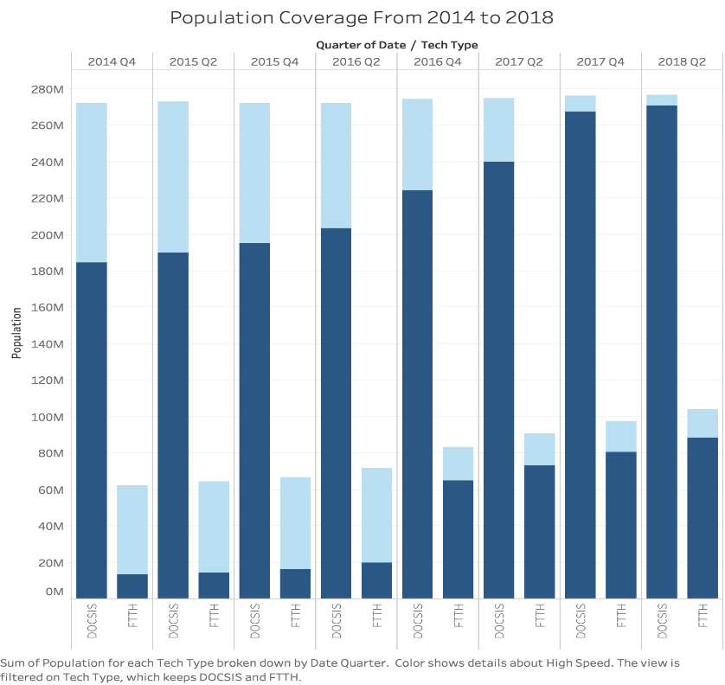

High Speed

Non-High Speed

*Figure 8*

Since most blocks are covered by traditional technology in 2014, we conjecture that the current available internet speed has an impact on determining whether FTTH should be developed in an area. In other words, areas which already have high-speed internet or areas which have a slow-speed internet might have different incentives to get FTTH implemented. High-speed internet is defined by any service provider which provides a maximum download speed over 100 Mbps. Therefore, we conduct a hypothesis testing to test whether areas with a high-speed internet in 2014 and areas without high-speed internet in 2014 will have the same chance to develop FTTH in 2018. The analysis is conducted in block level data and we only study blocks which did not have FTTH in 2014.

|  |  |  |
| --- | --- | --- |
|  | # Census Blocks | Census Blocks have FTTH in Jun 2018 |
| # Census Blocks did not have FTTH in Dec 2014 | 7260184 | 756516 |
| # Census Blocks did not have FTTH in Dec 2014 but have high speed internet (Group 1) | 2237073 | 328807 |
| # Census Blocks did not have FTTH in Dec 2014 and did not have high speed internet (Group 2) | 5023111 | 427709 |

*H0: Group 1 and Group 2 have the same mean in the number of blocks having FTTH in 2018 Jun*

*In choosing the places to expand the FTTH technology*

*H1*: *Group 1 and Group 2 have different means in the number of blocks having FTTH in 2018 Jun*

*In choosing the places to expand the FTTH technology*

Test Statistics:

t-value: -252.89161882316702,

p-value: 0.000002

*Table 2*

According to the testing statistics in table 2, we reject the null hypothesis. Blocks with high-speed internet before show a different preference in developing FTTH compared with blocks without high speed internet previously. In fact, blocks which had high-speed internet in 2014 are more likely to implement FTTH technology than those who did not. One possible explanation could be the residents living in the blocks with high-speed internet in 2014 are people either demands faster internet or have higher income than those who live in blocks that don’t have high-speed internet back in 2014. High-speed internet cost more money than low speed. With higher income level, it becomes easier for them to purchase FTTH.

**Conclusion**

1. We uploaded the interactive graph on the public GitHub repository (), where we can use the mouse to explore each ISP in the graph.
2. <https://www.otelco.com/fiber-infrastructure/>